**17.AWS-AutoScaling**

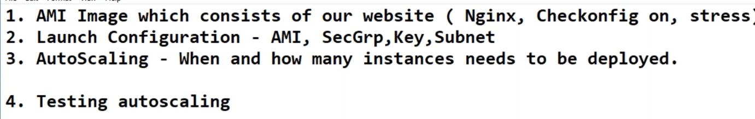

--- you are creating AMI and you must give this command in the AMI

--- **chkconfig nginx on** – this command will start the service even the server rebooted.

**Creating Load balancer**

We will create load balancer with empty target group. We don’t need to create target group here. The auto scaling will add the targets to the target groups.

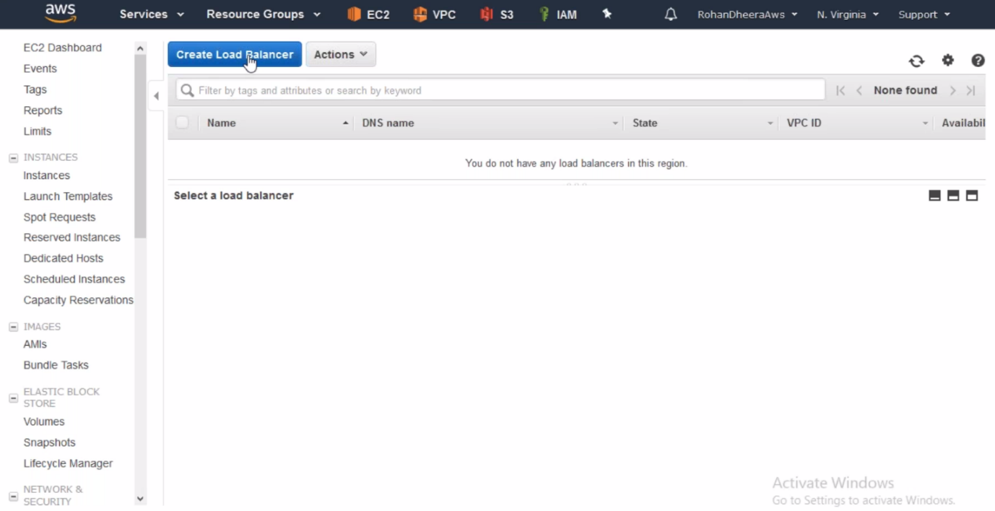

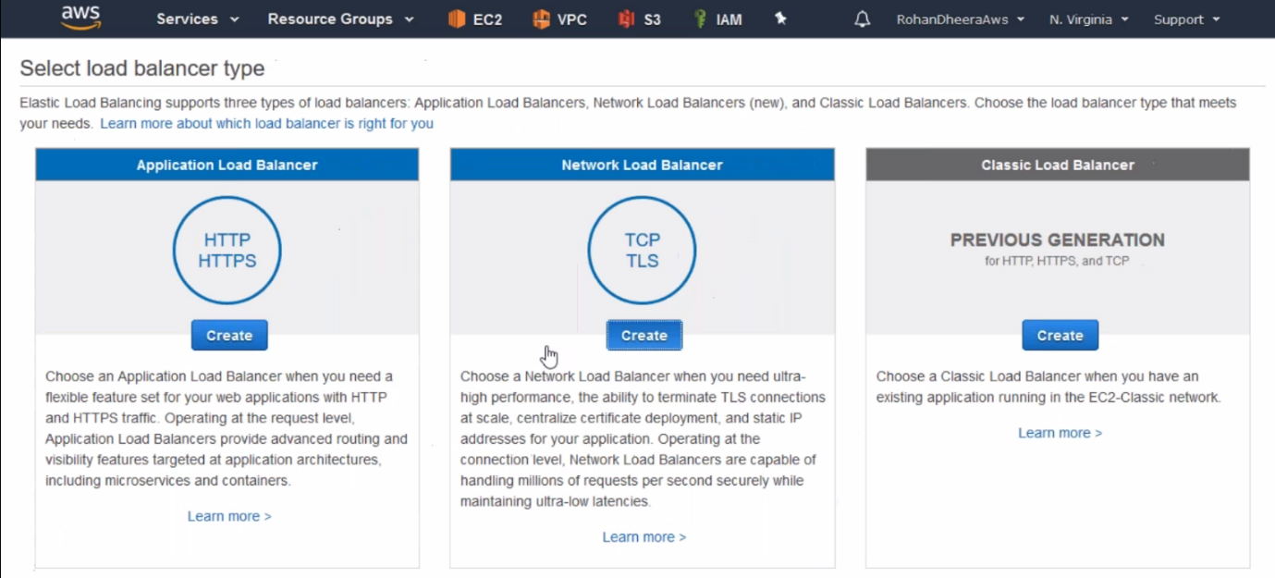

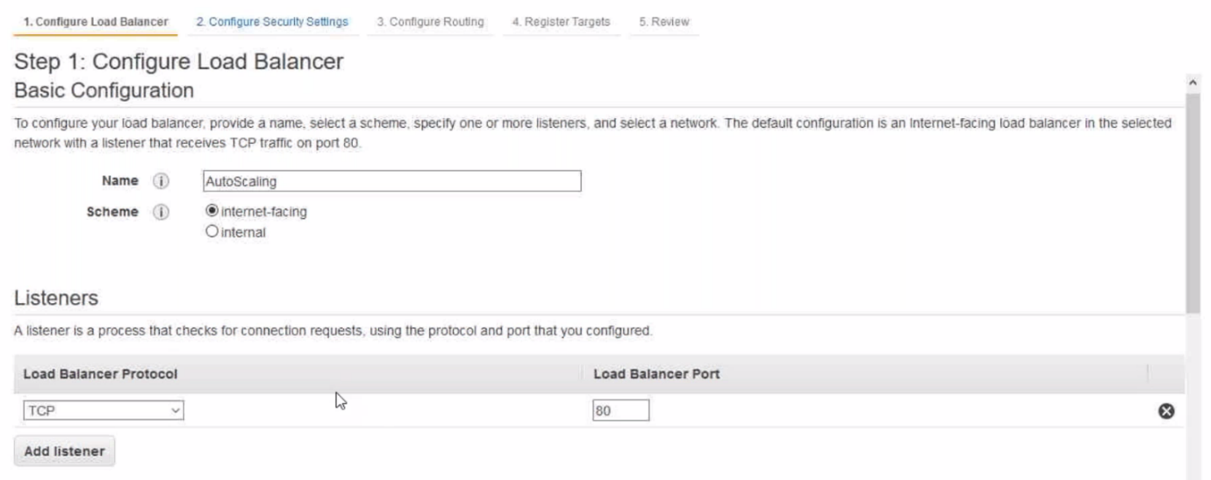

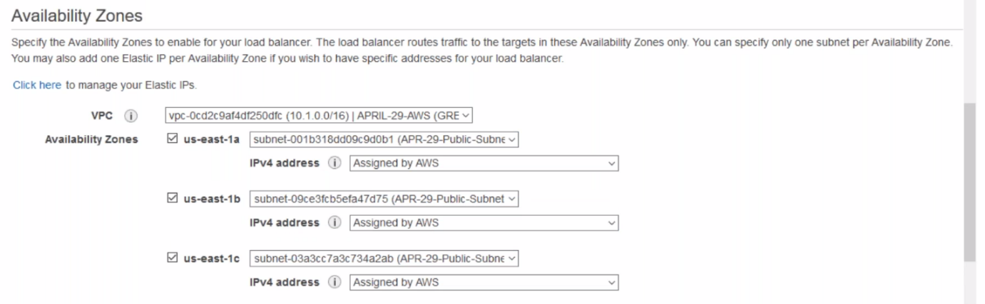

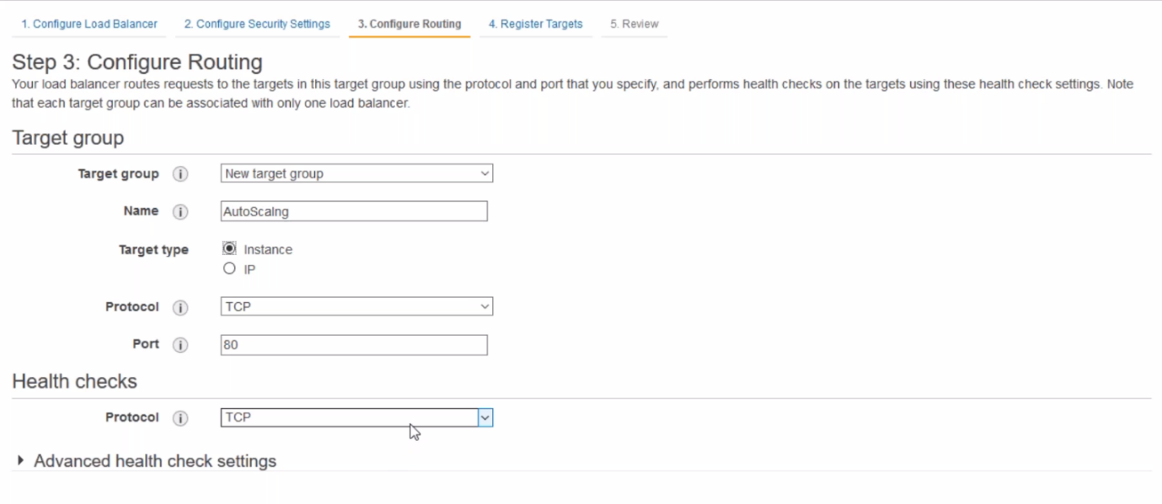

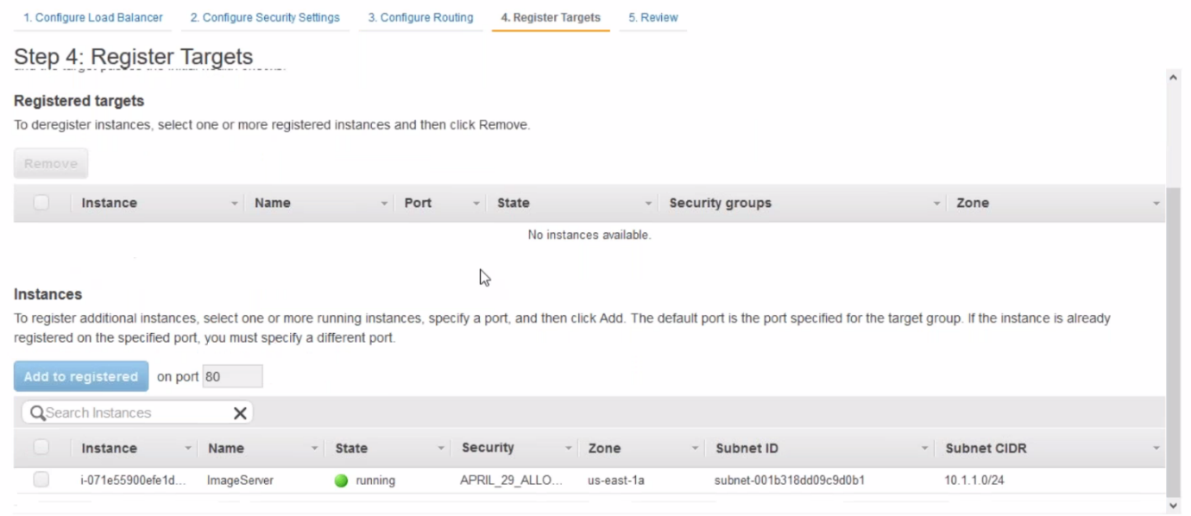

--- here don’t add any target groups and the load balancer will create with empty target group.

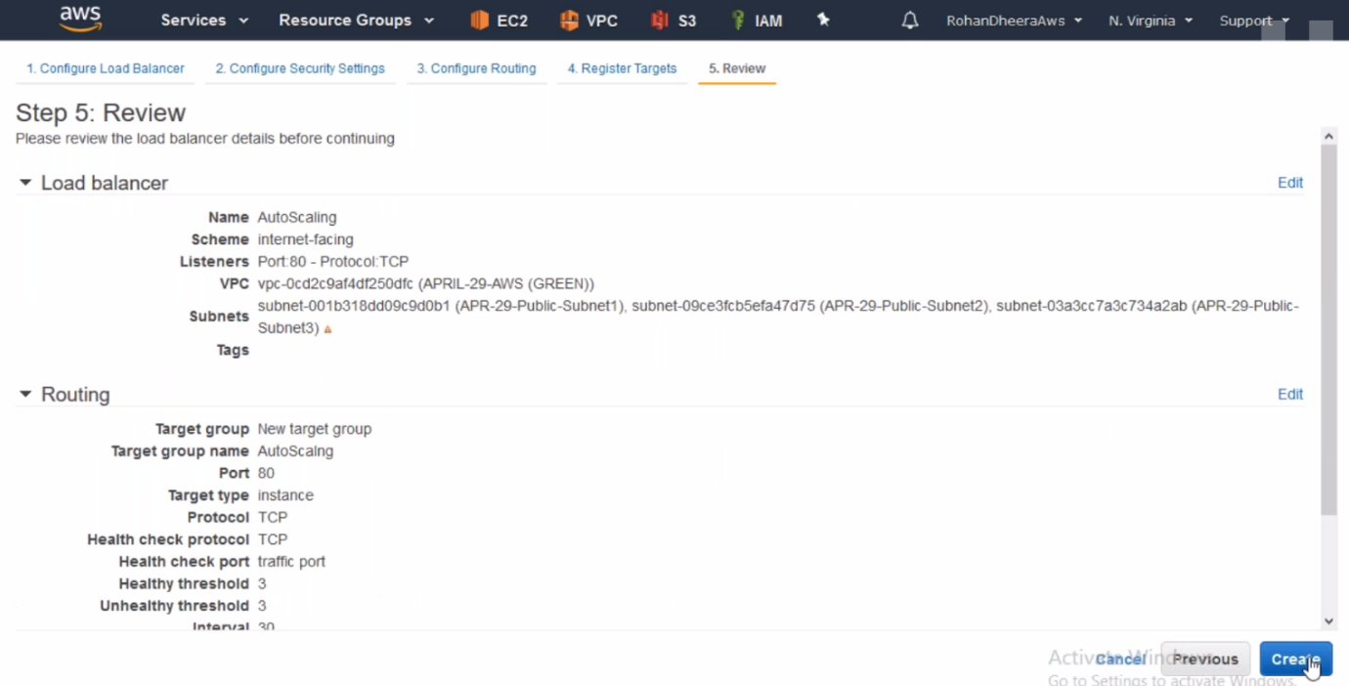

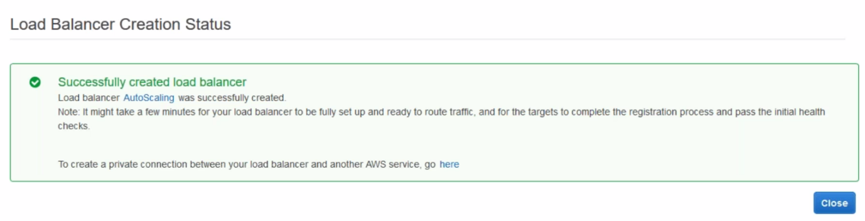

**Auto Scaling Group Creating**

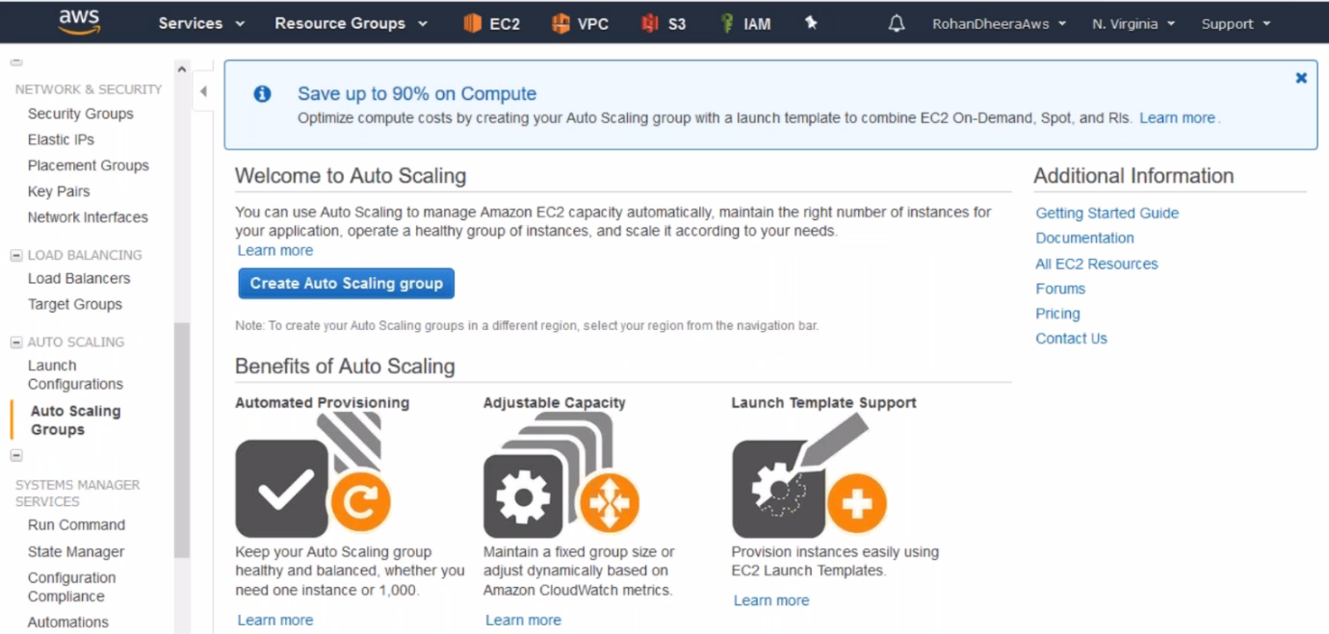

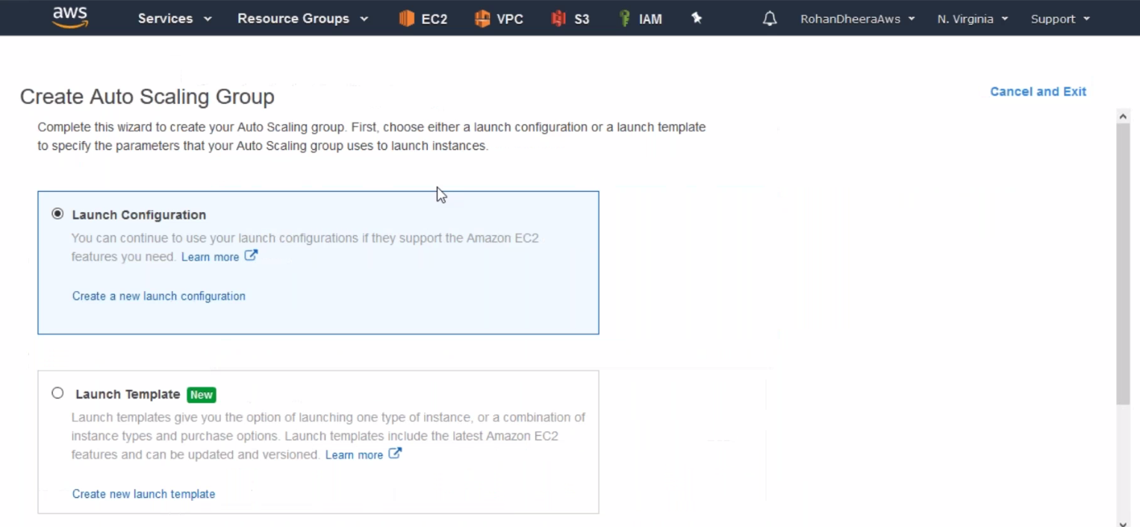

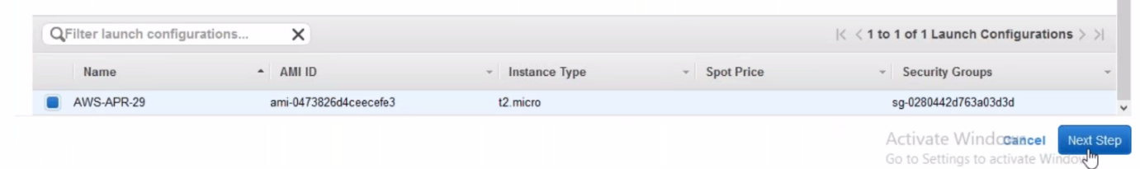

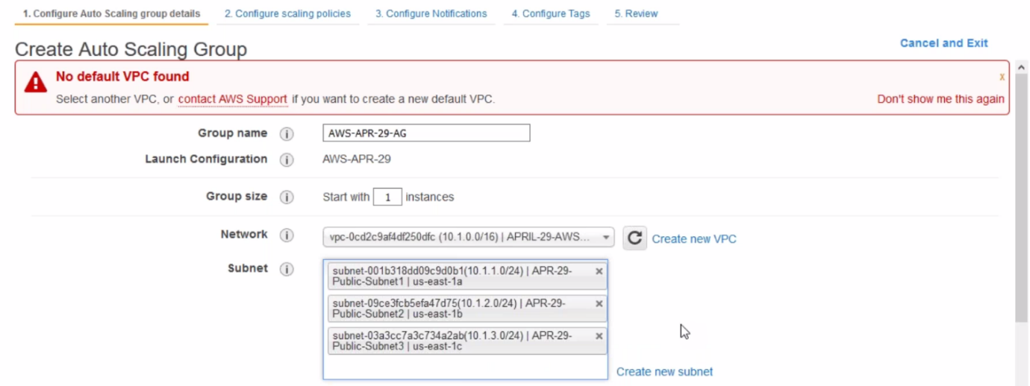

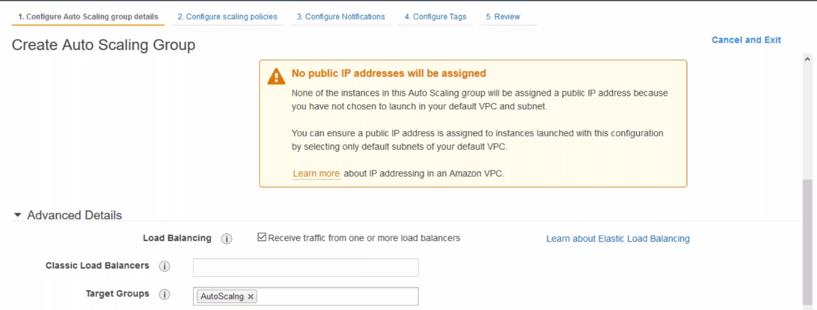

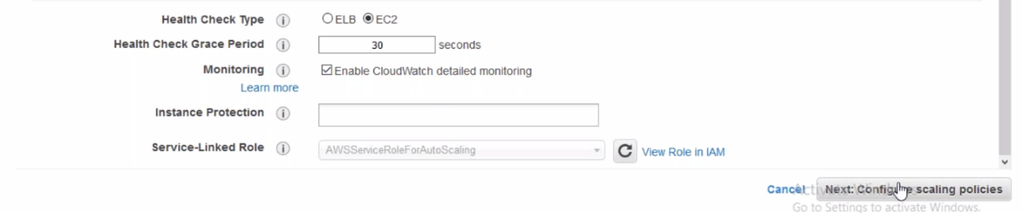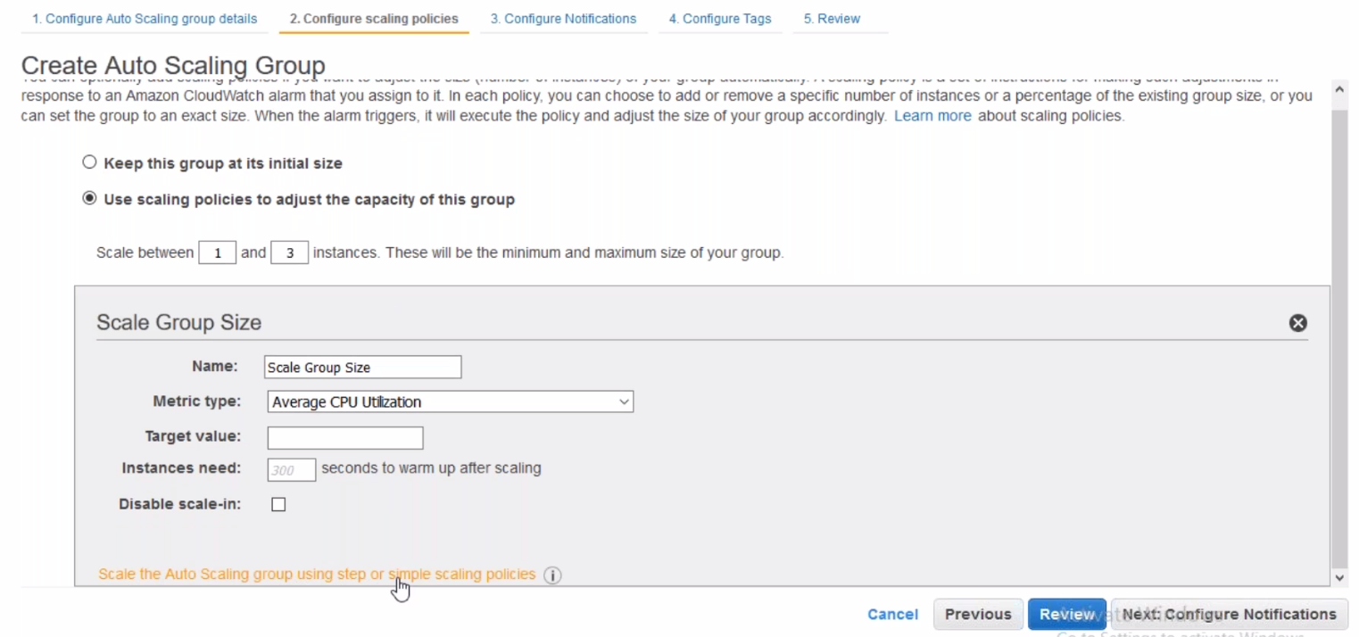

--- click on auto scaling group

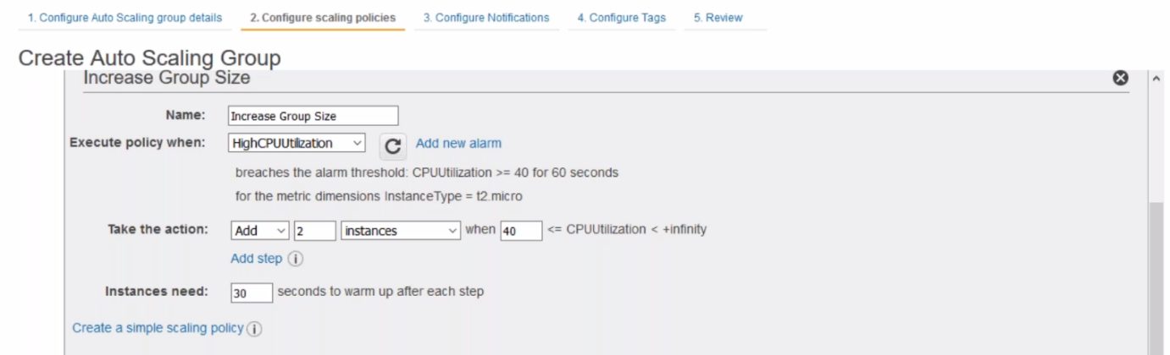

--- click on add new alarm

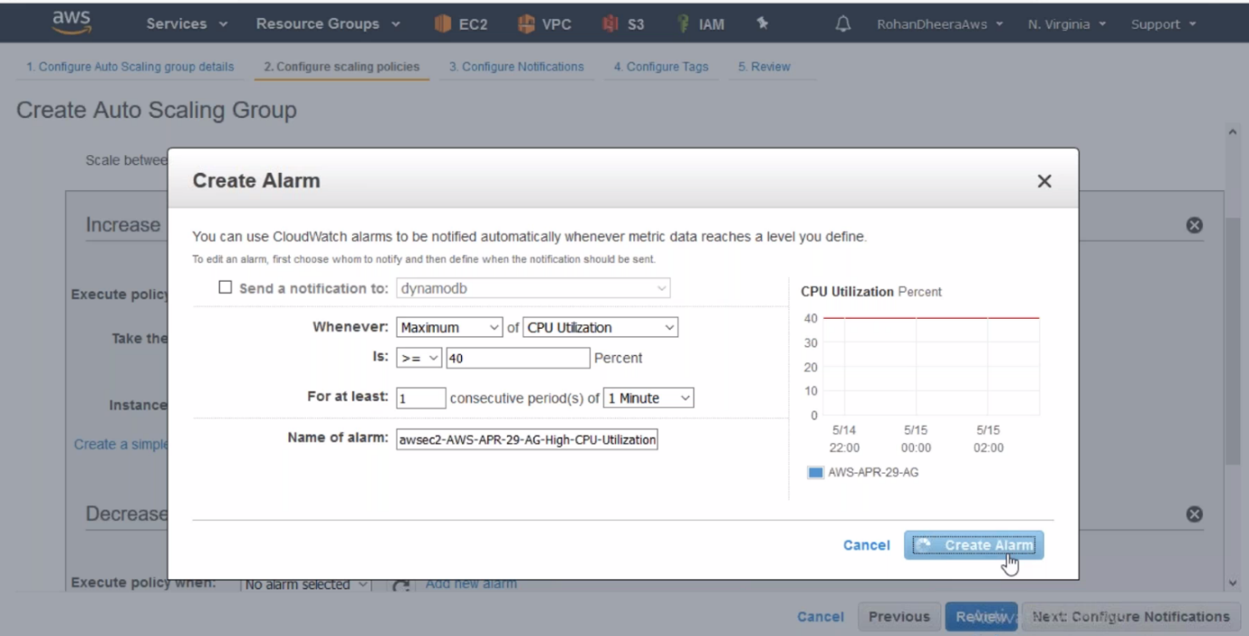

--- if the CPU utilization reaches above 40%, The auto scaling group will increase the instances.

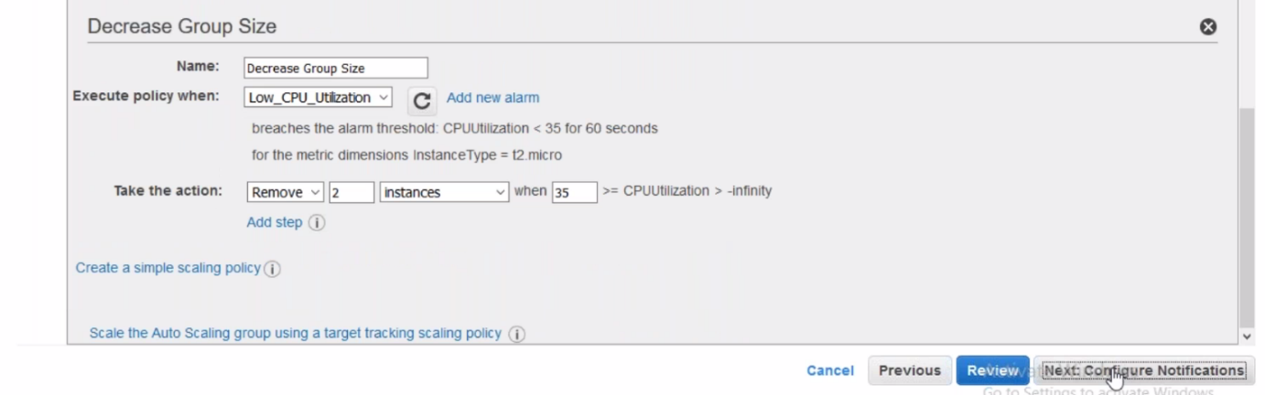

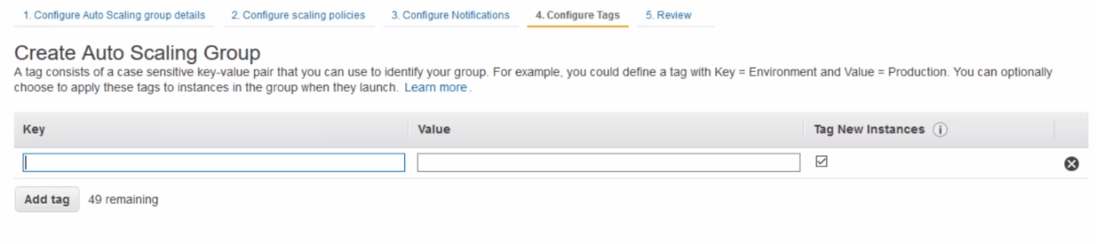

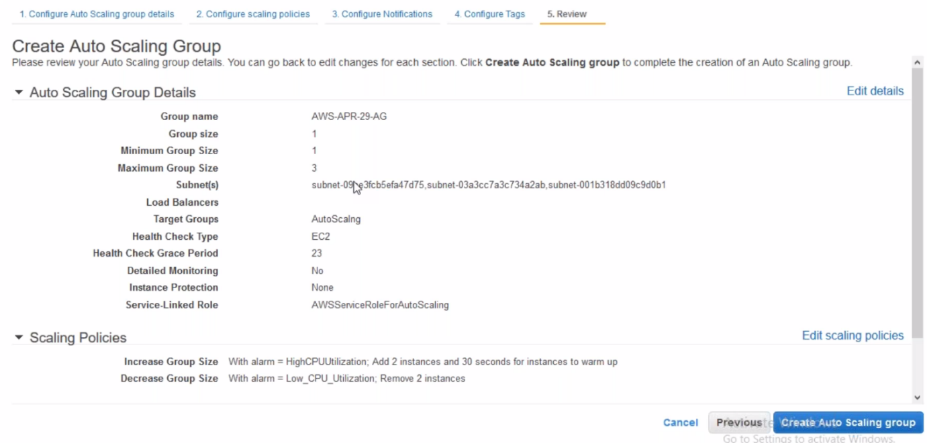

--- one instance will be started and the started instance added in target group. Login in to this instance and apply some stress.

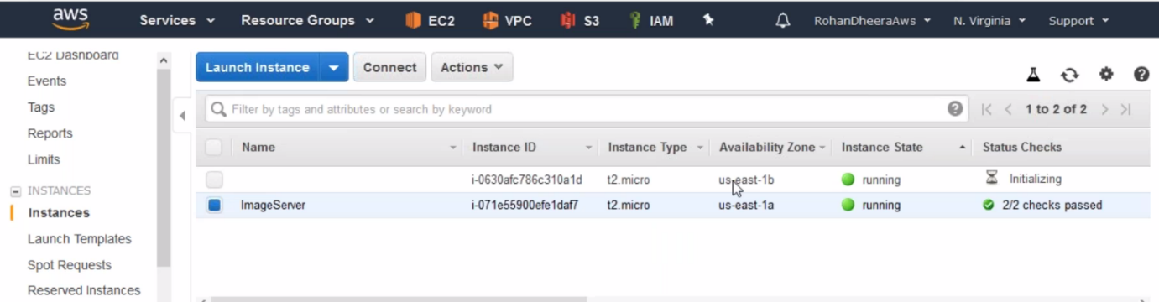

**Stress Applying on the server**

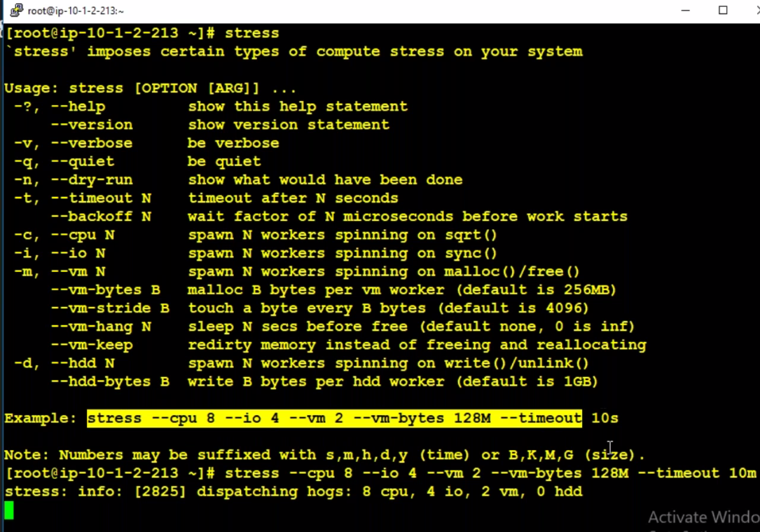  
--- the time out is 10s, change this 10s to 10min.

**Monitoring the instance CPU**

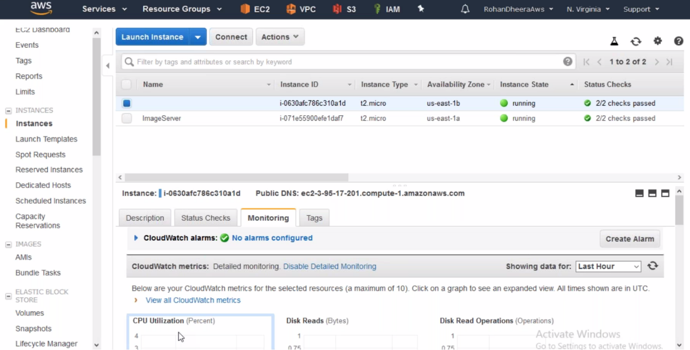

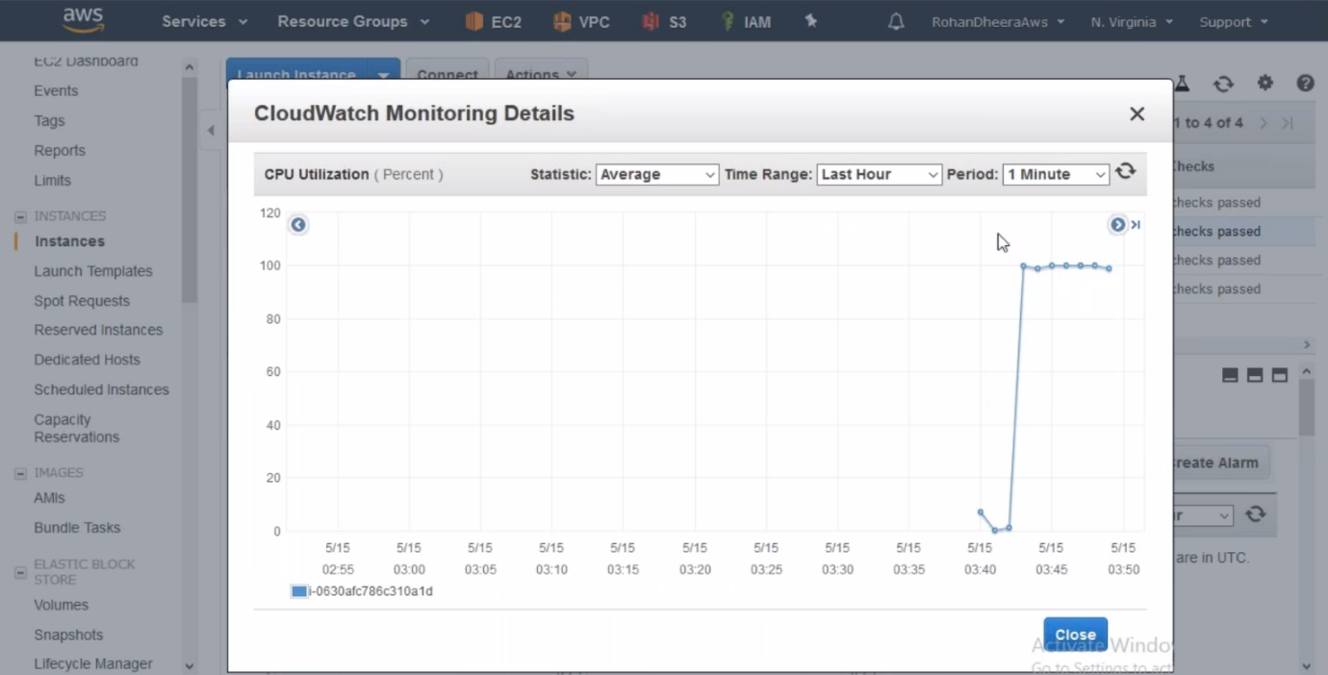

**Create Scheduled Action for autoscaling**

--- you want only 2 instance’s during sat-sud and this features will minimize or maximize to 2 instance no matter how many instance are running. The features is mainly for cost management.

